Hacking:
- Hacking Involves unauthorized or authorized access, manipulation, or exploitation of computer systems, networks, or data for various purposes.
Major Types of Hacking:
Black Hat Hacking
- Malicious activities for personal gain or harm. Also known as unethical hacking.
Motivations:
- Financial gain, political objectives, personal revenge or the thrill of breaking into secure systems.
Methods:
- Malware attacks, phishing, denial of service (DoS), SQL injection, man-in-the-middle attacks.
Tools:
- Metasploit, keyloggers, remote access Trojans (RATs), botnets.
Illegal Activities:
- Against the law, punishable by fines and imprisonment under laws like the Computer Fraud and Abuse Act (CFAA).
Dark Web Involvement:
- Operate on the dark web for anonymity, using cryptocurrencies for transactions (Mostly).
White Hat Hacking
- Authorized hacking to identify and fix vulnerabilities for security enhancement.
- This is also known as “Ethical Hacking” or “Penetration testing”.
Purpose:
- Strengthen security, protect against cyber threats, and safeguard sensitive data.
Types:
- Penetration Testing, Vulnerability Assessment, Security Auditing.
Authorized Access:
- Conducted with explicit permission from system owners.
Legal Framework:
- Operates within legal frameworks and compliance standards.
Tools and Techniques:
- Uses specialized tools like those employed by black hat hackers.
Scope:
- Covers web application security, network security, wireless security, and social engineering.
- Education and Training:
- Ethical hackers undergo specialized training to stay updated on the latest hacking techniques and defensive strategies.
Methods:
Automated tools identify open ports and vulnerabilities in networks and systems.
Vulnerability Assessment: Systematic review to identify, quantify, and prioritize software and system vulnerabilities.
Penetration Testing: Simulates cyber-attacks to exploit vulnerabilities and evaluate existing security measures.
Social Engineering: Manipulating individuals to disclose confidential information through techniques like phishing.
Wireless Network Testing: Assessing the security of wireless networks to identify and address vulnerabilities.
Web Application Testing: Evaluating web applications for vulnerabilities like SQL injection and XSS.
Password Cracking: Testing password strength to assess and improve password policies.
Security Auditing: Comprehensive analysis of security policies, procedures, and infrastructure.
Physical Security Assessment: Evaluating physical security measures, such as access controls.
Post-Exploitation: Assessing the extent of system compromise after initial access is gained.

Contactless Payment:
Definition:

- Secure payment method without physical contact between the payment device and terminal.
Technology:
- Utilizes RFID or NFC for seamless transaction information exchange.
- Swift purchases by tapping contactless cards or mobile devices near compatible terminals.
Benefits:
- Faster and streamlined transactions compared to traditional methods.
- Eliminates card insertion or PIN entry for small transactions.
- Globally adopted, with increasing merchant acceptance.
Devices:
- Commonly used with contactless cards and mobile solutions like Apple Pay, Google pay, Samsung pay etc.
Limits:
- Has transaction limits, requiring additional verification for larger amounts.
Integration:
- Integrated into daily life, from retail to public transportation.
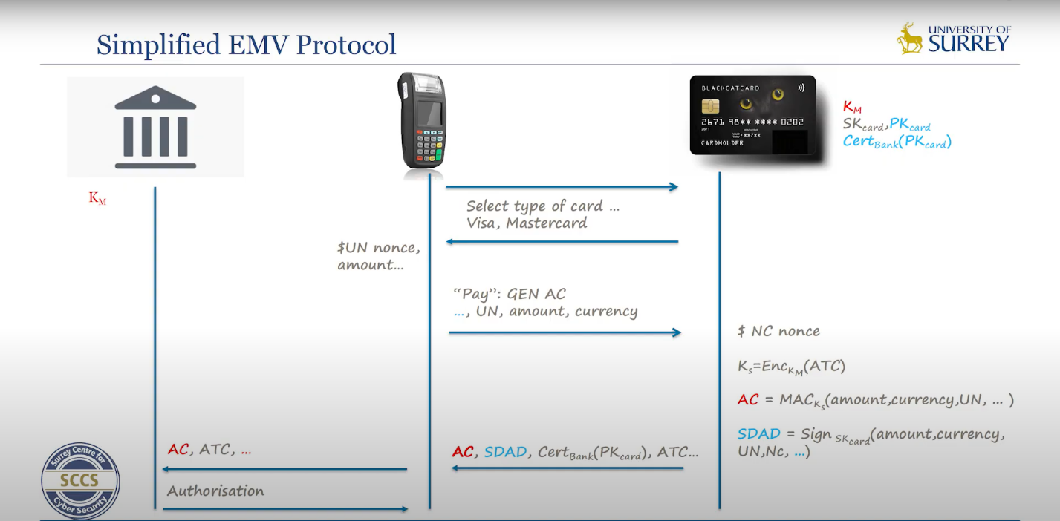

Case Study:
"Addressing the Vulnerabilities: A Case Study on the Security Risks in Visa and Apple Pay Transactions"
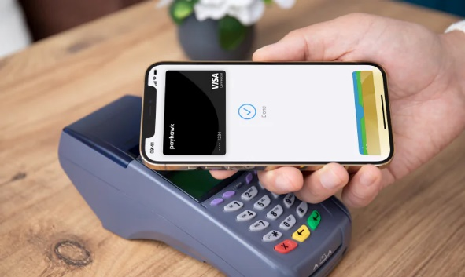
Then we will come to the problem statement
Problem:
“The main problem with the Visa and Apple Pay vulnerability lies in the potential exploitation of weaknesses in transaction security protocols, risking unauthorized access and potential financial losses for users."
Components used in the attack:
- Any Android phone.
- Programmable NFC device.
- A device used as a server to run the Python code.
- An EVM reader/Terminal.
Attack scenario:
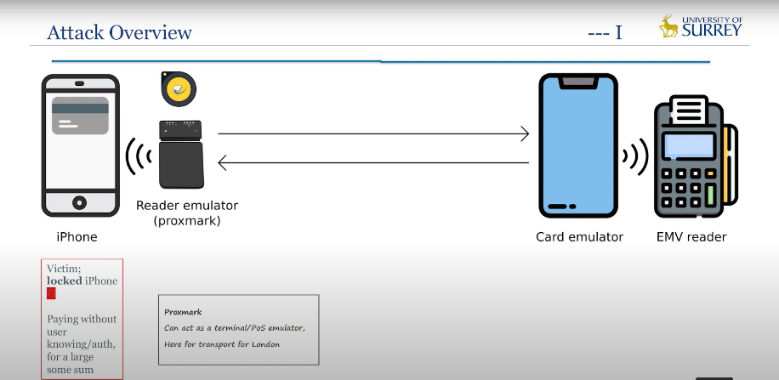

Steps:
Step 1:
NFC Communicates with the iPhone. To initiate the transaction
Step 2:
registered terminal initiates a payment request to the card emulator device (the Android phone).
Step 3:
The NFC device intercepts data from the terminal, manipulates it, and falsely presents itself to the victim's iPhone as a transportation terminal, prompting the iPhone to make a payment without requiring authentication.
Step 4:
The iPhone approves the payment while indicating a lack of authentication.
Step5:
"When information transitions from the NFC device to the Emulator device, subsequent manipulation by Python code falsely signals to the terminal that user authentication has occurred, meeting the terminal's requisite for payment processing."

Easy Counter measures for Apple-VISA Attack
VISA check the IAD and /or MCC Checking for the activities.
Apple pay allow only 0 value payments for transport Samsung pay case.
Deploy relay-protected protocols Time measurement.

Conclusion:
Transport Mode Exploitation in Apple Pay and Samsung Pay.

